

Lab No:05 Date:2082/09/13
Title: Studying Triggers with practical implementation in Oracle.
A trigger is a stored PL/SQL block that automatically executes in response to a specific event on a table or view. Triggers are mainly used to enforce rules, maintain audit trails, or perform automatic actions without manual intervention. riggers are automatic, event-driven procedures that help enforce business rules or maintain data integrity without manual intervention.
Types of Triggers in Oracle:
- Based on Timing (When the trigger fires):
1.BEFORE Trigger
-Executes before the triggering event (INSERT, UPDATE, DELETE).
-Used for validating or modifying data before it is stored.
2. AFTER Trigger
-Executes after the triggering event.
-Used for logging, auditing, or cascading changes.
B. Based on Scope (How many rows it affects)
1.Row-Level Trigger (FOR EACH ROW)
-Fires once for each row affected by the operation.
-Can access :NEW (new value) and :OLD (old value).
2.Statement-Level Trigger
-Fires once per SQL statement, regardless of how many rows are affected.
C. Based on Event Type
- INSERT Trigger – Fires when rows are inserted.
- UPDATE Trigger – Fires when rows are updated.
- DELETE Trigger – Fires when rows are deleted.
- Combined Events – One trigger can handle multiple events:

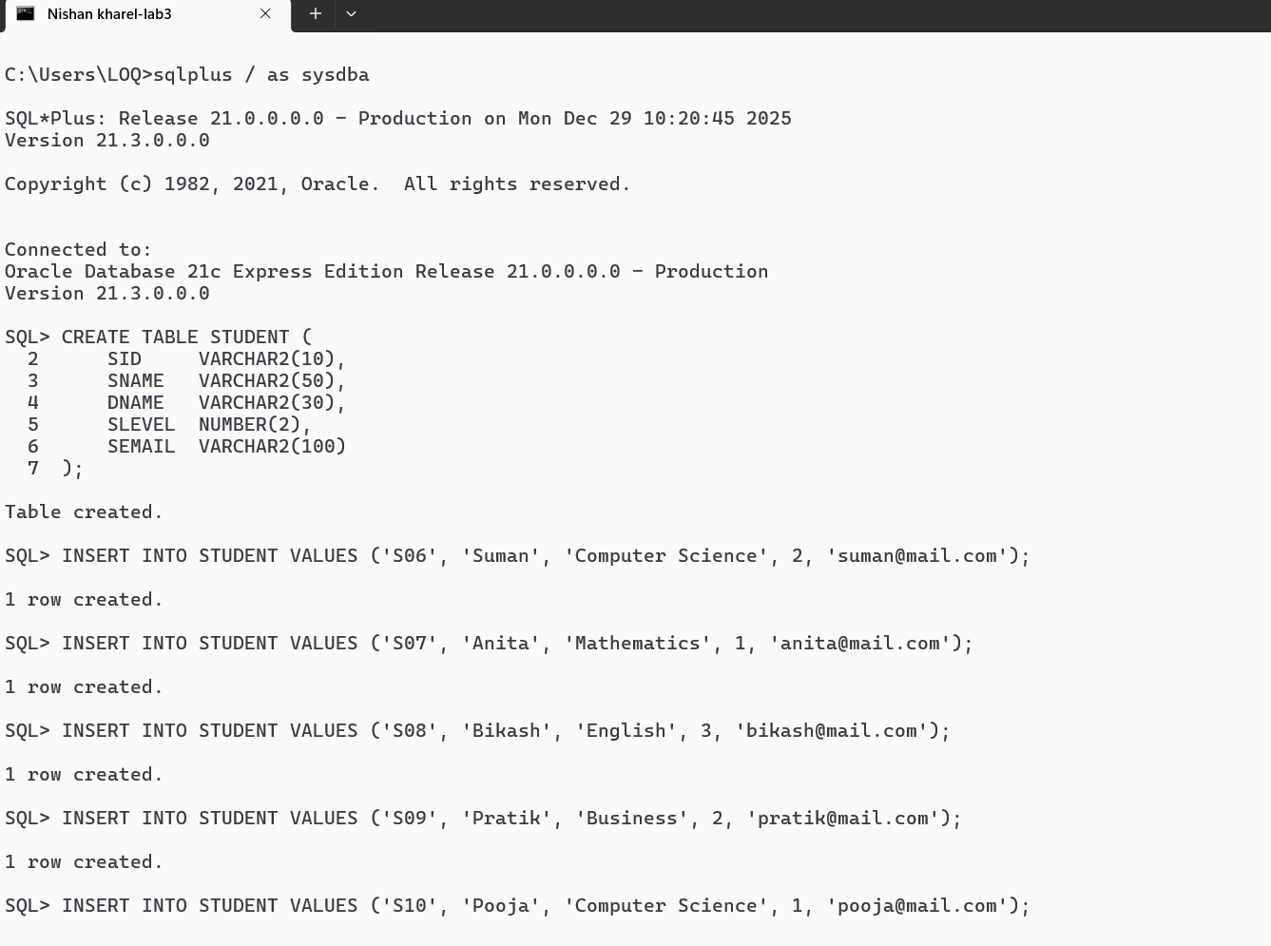
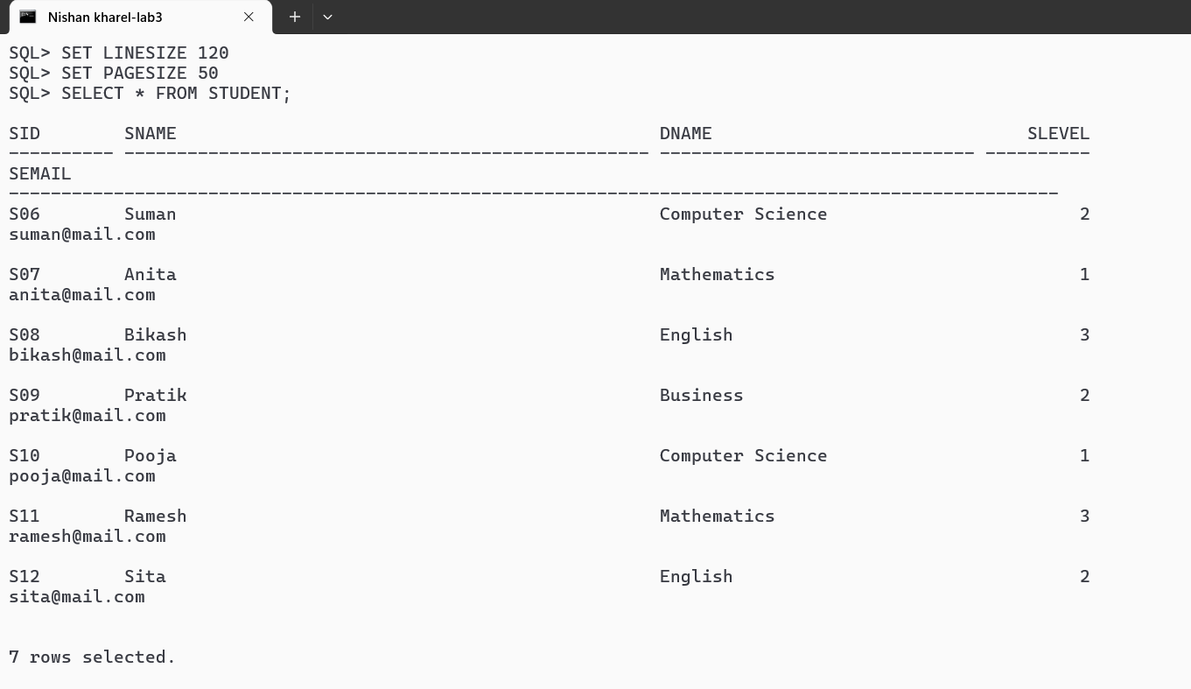
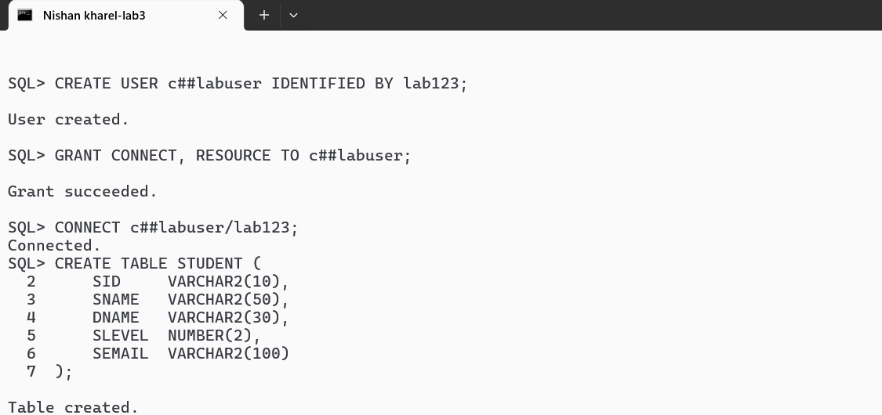
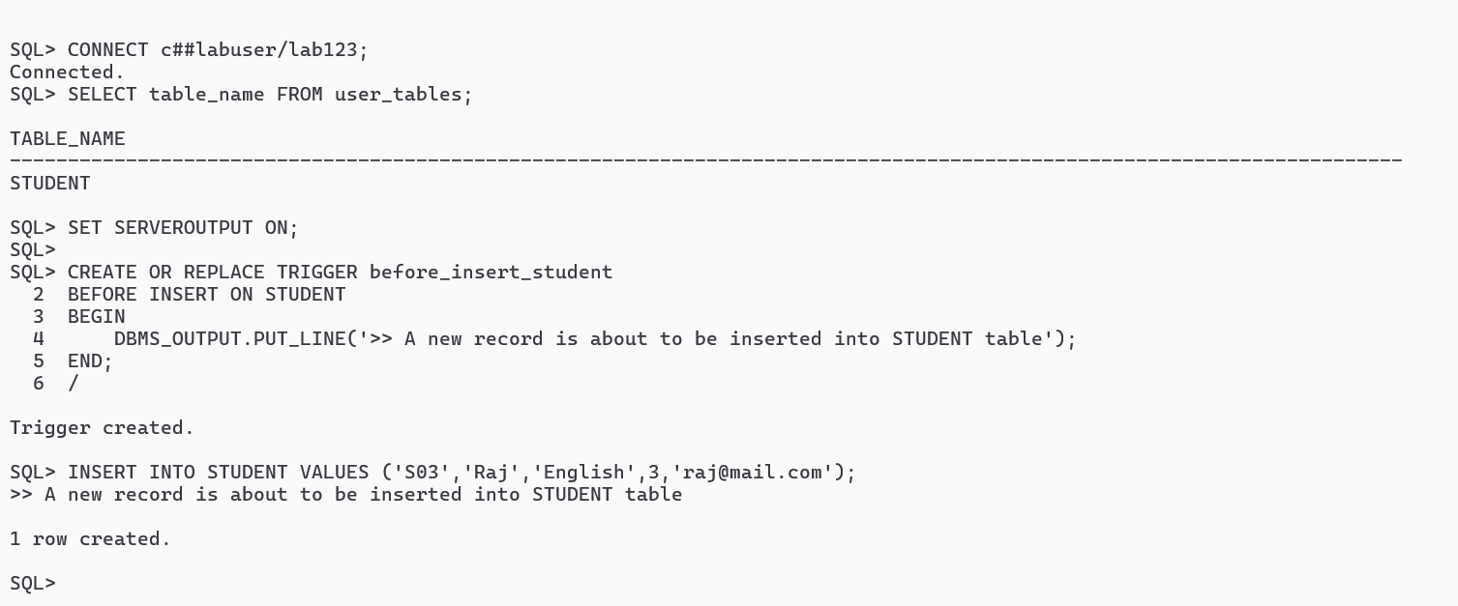
Set up an Oracle Database environment and worked through some initial access issues. I started by connecting as SYSDBA and creating a STUDENT table with fields for student ID, name, department, level, and email, then inserted seven student records. When we tried to create a trigger on the SYS-owned table, I encountered an error because triggers can't be created on SYS objects. To fix this, I created a new common user called c##labuser with proper privileges, granted it CONNECT and RESOURCE roles, and connected as that user. After resolving a tablespace quota issue by granting unlimited quota on the USERS tablespace, you recreated the STUDENT table under this new user account and re-inserted all seven records (which resulted in duplicates in the SYS schema). Finally, We successfully created a BEFORE INSERT trigger that displays a message when new records are inserted, and tested it by inserting a new student record for 'Raj', which triggered the output message as expected.
- AFTER INSERT Trigger
First, let's create an AFTER INSERT trigger that executes after a record is inserted:
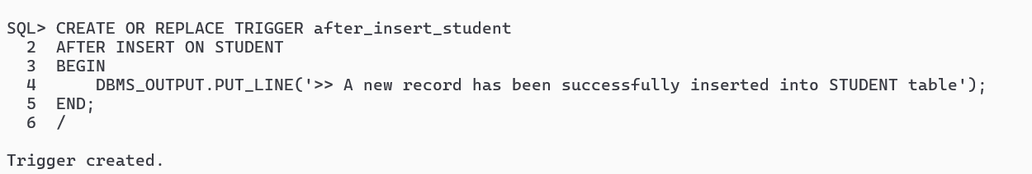

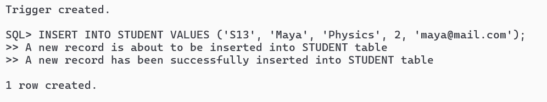

B . Row-Level Trigger with :NEW
Next, let's create a row-level trigger that can access the actual data being inserted:
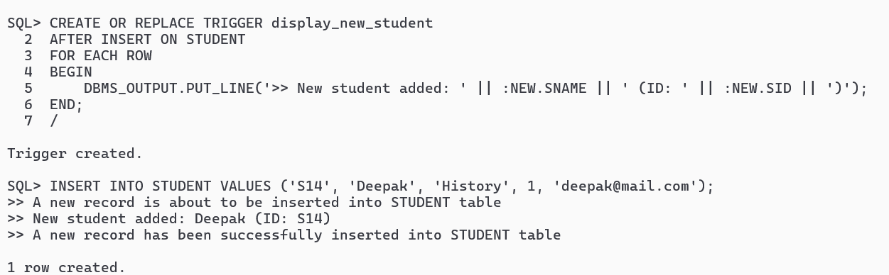

c. BEFORE UPDATE Trigger
This trigger will fire before any record is updated:
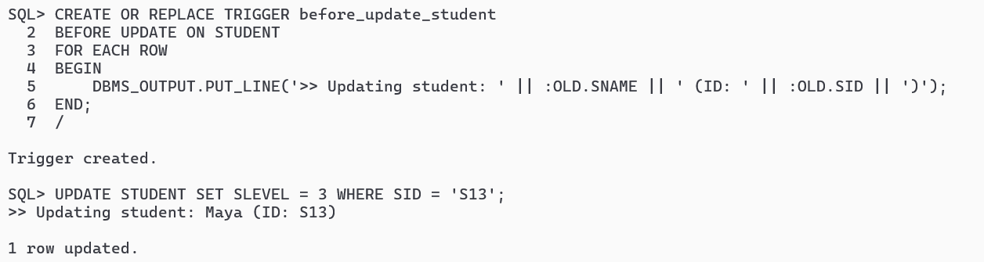

d.AFTER UPDATE Trigger with OLD and NEW values
This trigger shows both the old and new values during an update:
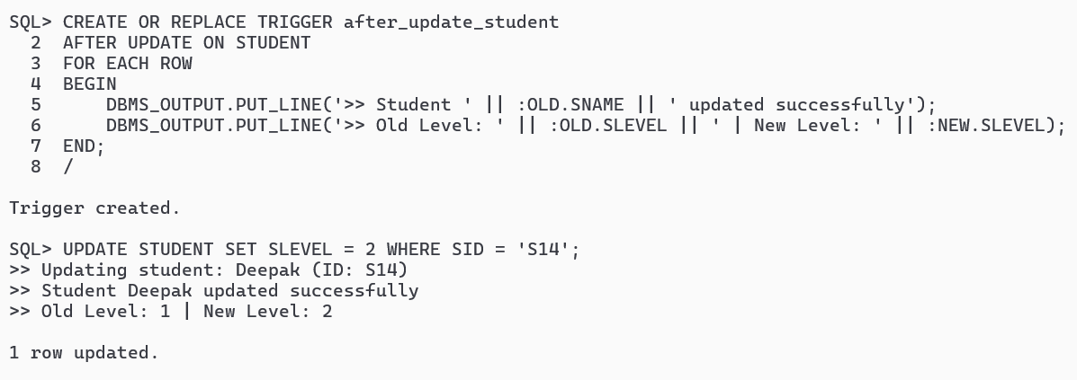

e.BEFORE DELETE Trigger
This trigger will fire before a record is deleted:
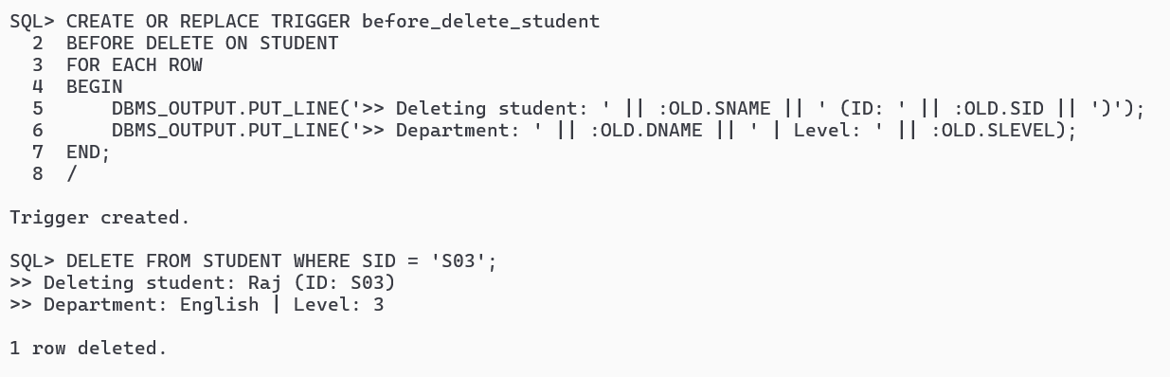

f. AFTER DELETE Trigger
This trigger executes after a record is deleted:
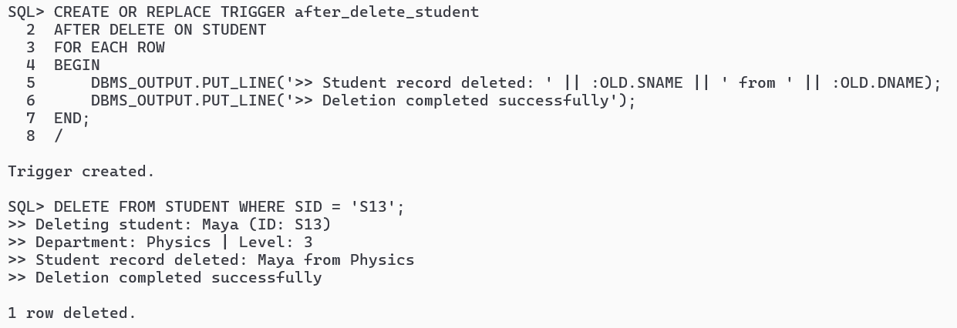
g. Composite Trigger (INSERT OR UPDATE OR DELETE)
This single trigger can handle multiple DML operations:
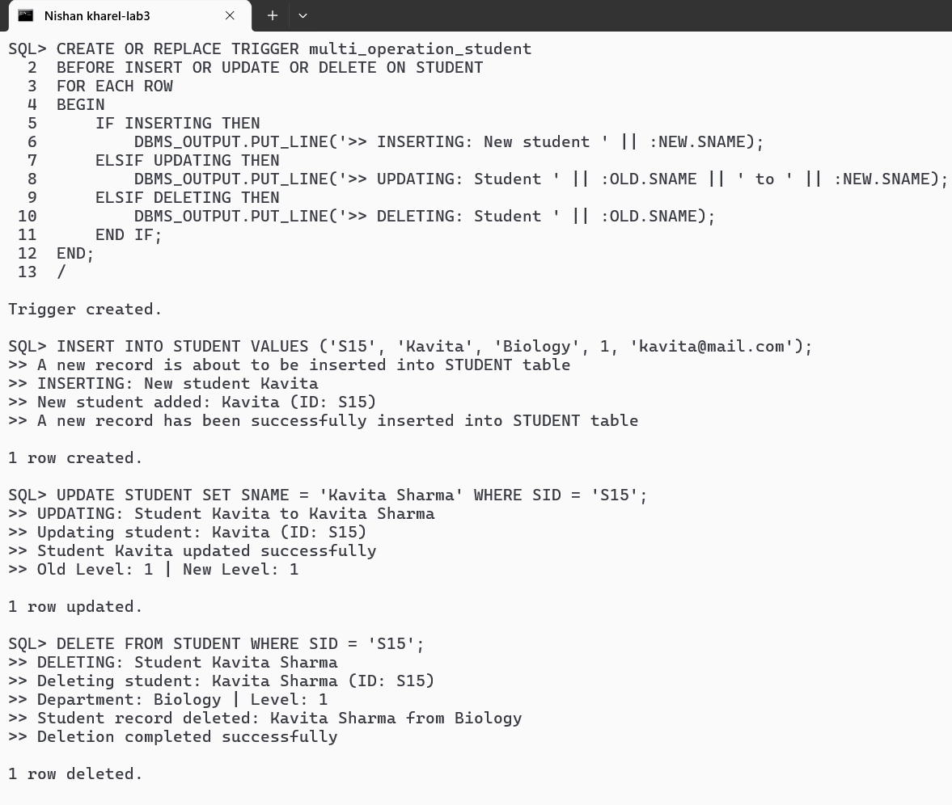

h.Conditional Trigger with WHEN Clause
This trigger only fires when a specific condition is met:
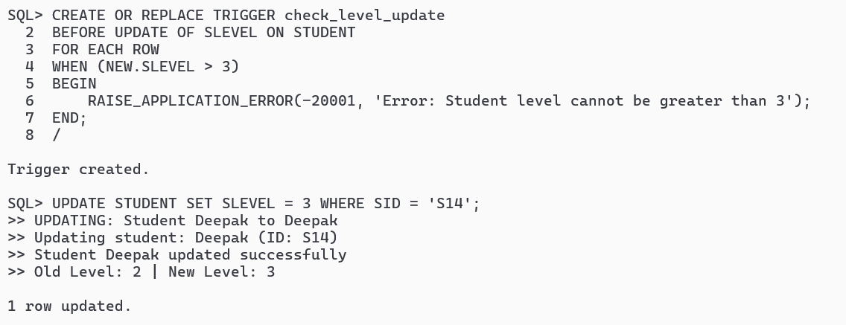
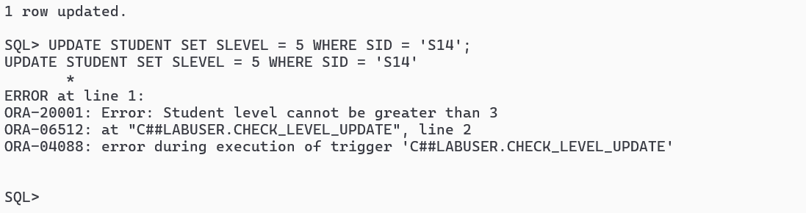
i.Trigger to Prevent Operations on Specific Days
This trigger restricts DML operations on weekends:
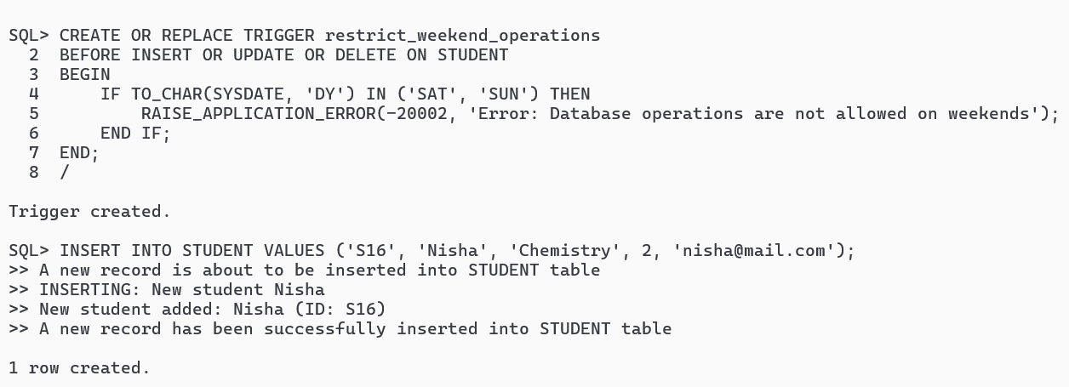

To view all the trigger implemented till now is listed below:

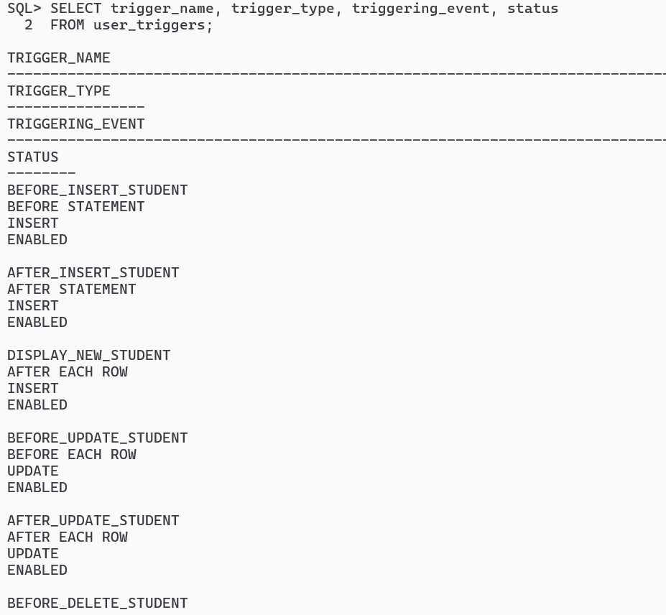
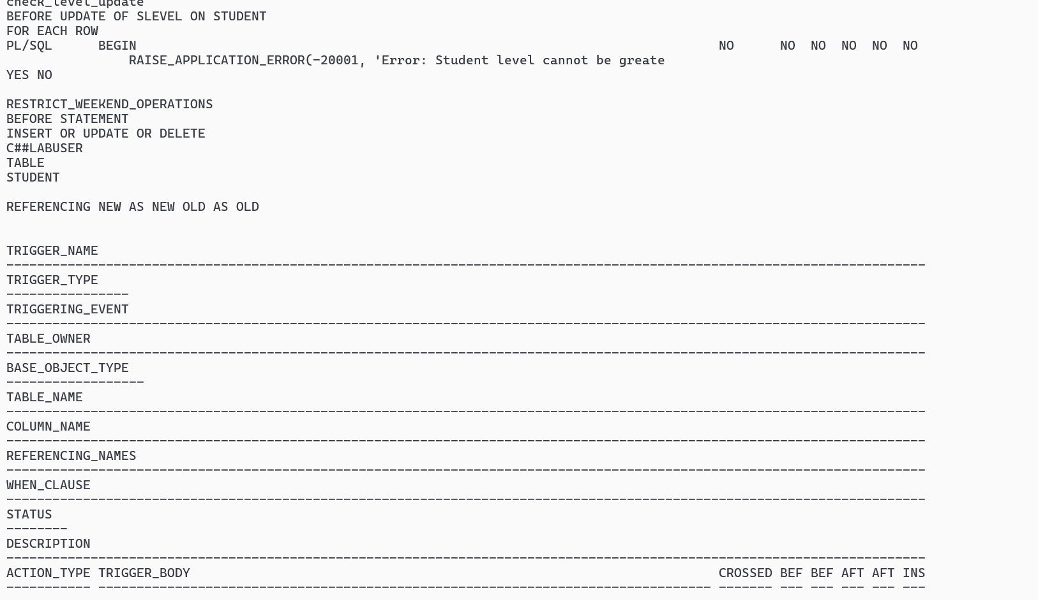

j. Audit Trail Trigger - Track All Changes

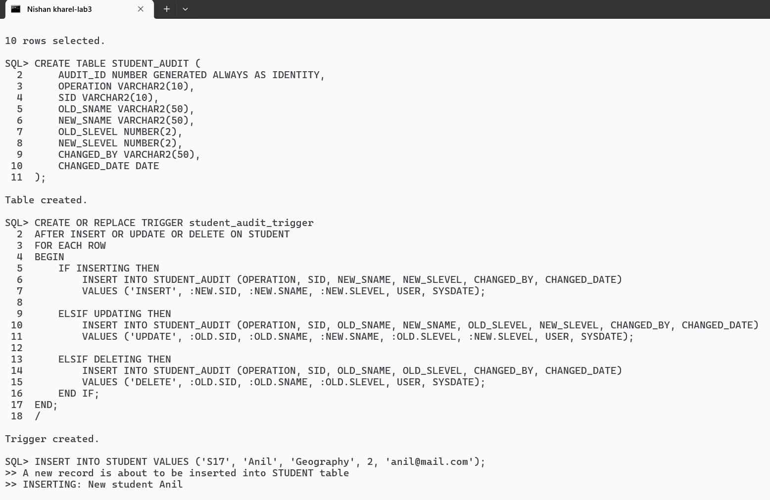
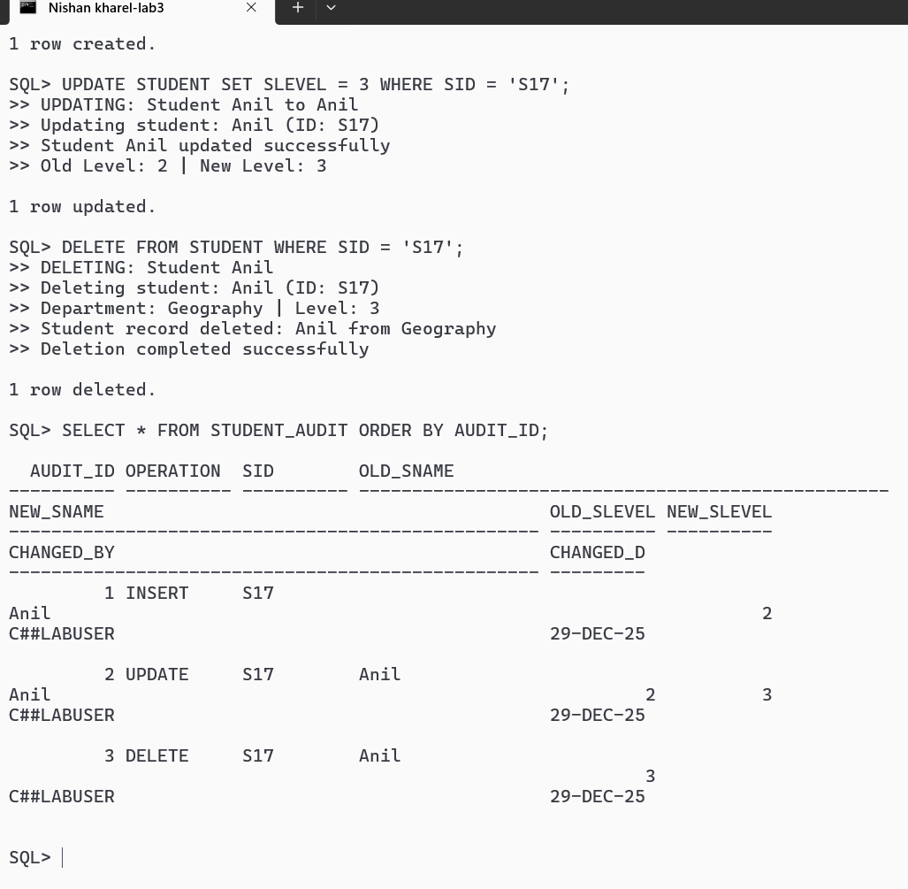

k.Compound Trigger with Multiple Timing Points
Compound triggers allow you to execute code at different timing points in a single trigger. This is very powerful for complex operations:
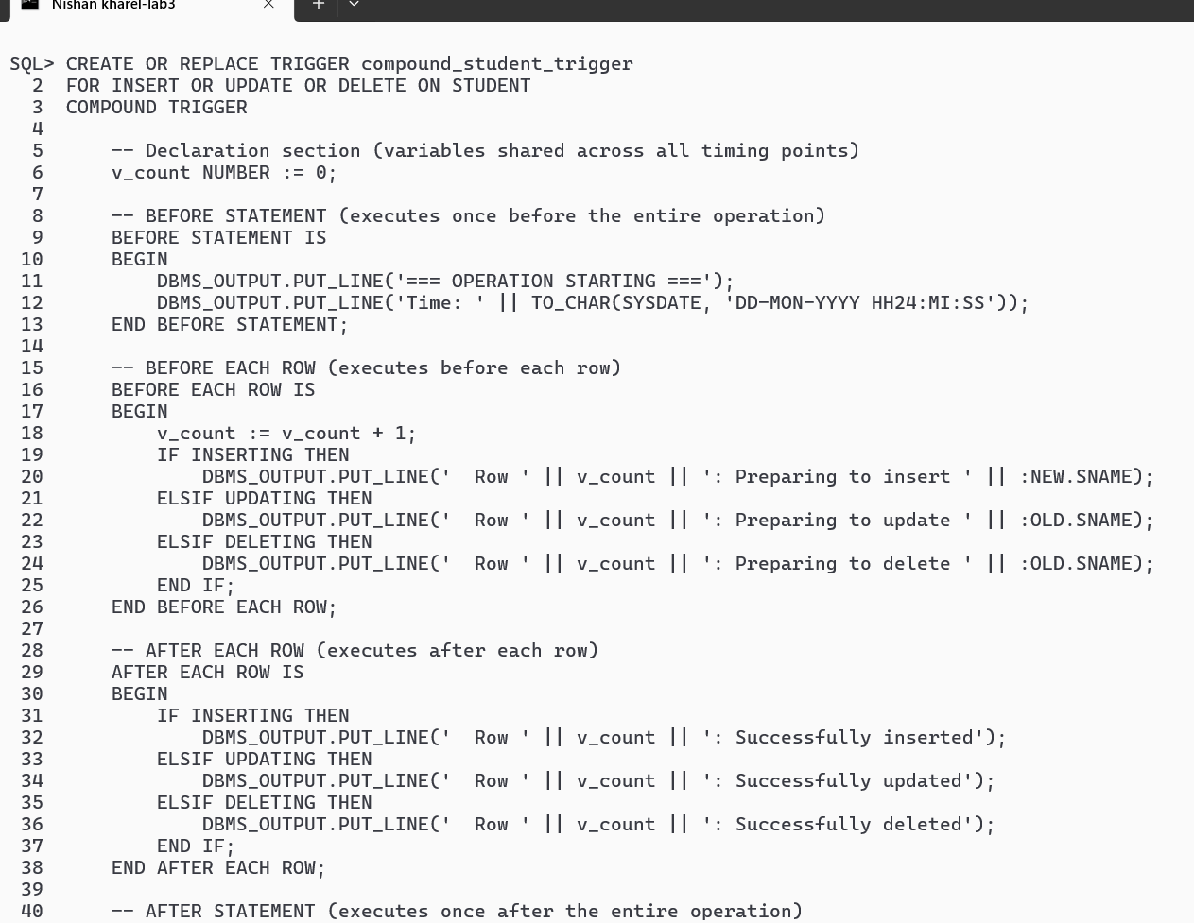
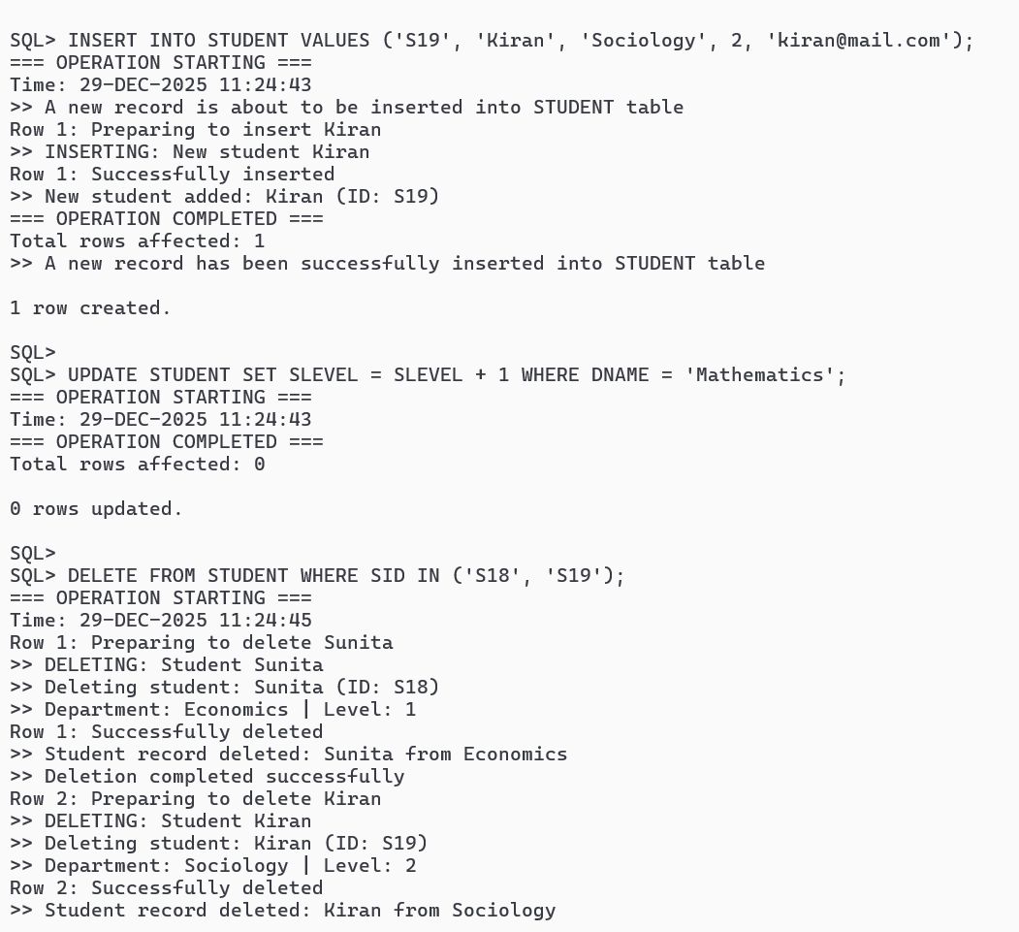
Conclusion:
In this lab, we successfully explored Oracle Database triggers from basic to advanced levels. We started by setting up a proper database environment, creating a common user (c##labuser) and the STUDENT table. We then implemented various trigger types including BEFORE and AFTER triggers for INSERT, UPDATE, and DELETE operations, demonstrating both statement-level and row-level triggers. We learned to access old and new values using :OLD and :NEW pseudo-records, implemented conditional triggers with WHEN clauses, and created business rule validations. Advanced concepts covered included composite triggers handling multiple DML operations, audit trail mechanisms using a separate STUDENT_AUDIT table to track all changes, time-based and day-based restrictions on database operations, and compound triggers with multiple timing points (BEFORE STATEMENT, BEFORE EACH ROW, AFTER EACH ROW, AFTER STATEMENT). We also learned essential trigger management commands to view, enable, and disable triggers, and understood the mutating table error and how to resolve trigger conflicts. This comprehensive hands-on experience demonstrated how triggers serve as powerful tools for enforcing data integrity, automating tasks, maintaining audit trails, and implementing complex business logic directly at the database.

